**4.3 Perancangan Basis Data**

**4.3.1 Skema Relasi Basis Data**

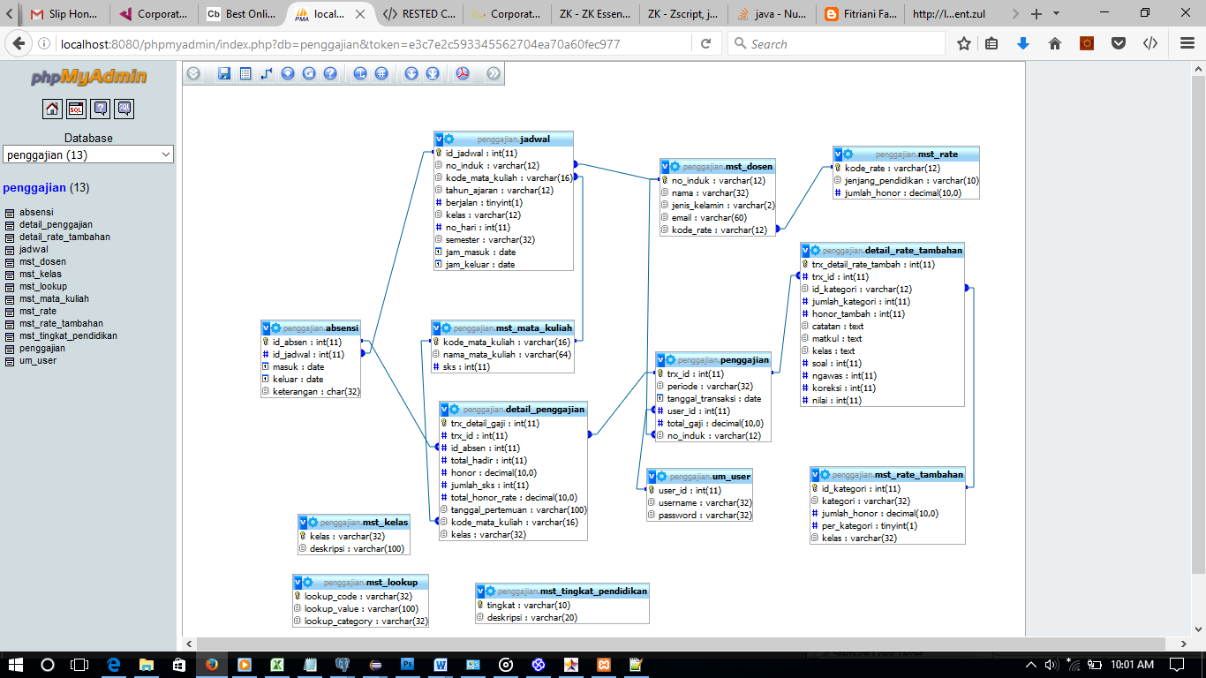

**Gambar 4.23** Skema Relasi Basis Data

4.3.2 Deskripsi Tabel

1. Tabel mst_dosen

Fungsi : menyimpan data dosen

*Primary Key* : no_induk

Struktur tabel :

|  |  |  |  |  |
| --- | --- | --- | --- | --- |
| No. | Nama Field | Tipe | Lebar | Keterangan |
| 1. | no_induk | Varchar | 12 | Primary key |
| 2. | nama | varchar | 32 |  |
| 3. | jenis_kelamin | varchar | 2 |  |
| 4. | email | Varchar | 60 |  |
| 5. | kode_rate | Varchar | 12 | Foreign key |

**Tabel 4.1** Deskripsi Tabel mst_dosen

1. Tabel mst_rate

Fungsi : menyimpan data *rate/*honor dosen berdasarkan jenjang pendidikannya.

*Primary Key* : kode_rate

Struktur tabel :

|  |  |  |  |  |
| --- | --- | --- | --- | --- |
| No. | Nama Field | Tipe | Lebar | Keterangan |
| 1. | kode_rate | Varchar | 12 | Primary key |
| 2. | jenjang_pendidikan | Varchar | 10 |  |
| 3. | jumlah_honor | Int | 11 |  |

**Tabel 4.2** Deskripsi Tabel mst_rate

1. Tabel mst_mata_kuliah

Fungsi : menyimpan data mata kuliah

*Primary Key* : kode_mata_kuliah

Struktur tabel :

|  |  |  |  |  |
| --- | --- | --- | --- | --- |
| No. | Nama Field | Tipe | Lebar | Keterangan |
| 1. | kode_mata_kuliah | Varchar | 16 | Primary key |
| 2. | nama_mata_kuliah | Varchar | 32 |  |
| 3. | sks | Int | 11 |  |

**Tabel 4.3** Deskripsi Tabel mst_mata_kuliah

1. Tabel mst_rate_tambahan

Fungsi : menyimpan data *rate/*honor tambahan dosen seperti honor membuat soal, mengoreksi, mengawas, dan lain-lain.

*Primary Key* : id_kategori

Struktur tabel :

|  |  |  |  |  |
| --- | --- | --- | --- | --- |
| No. | Nama Field | Tipe | Lebar | Keterangan |
| 1. | id_kategori | Int | 11 | Primary key |
| 2. | kategori | Varchar | 32 |  |
| 3. | jumlah_honor | Int | 11 |  |
| 4. | per_kategori | Tinyint | 1 |  |
| 5. | kelas | Varchar | 32 |  |

**Tabel 4.4** Deskripsi Tabel mst_rate_tambahan

1. Tabel jadwal

Fungsi : menyimpan data jadwal mengajar dosen.

*Primary Key* : id_jadwal

Struktur tabel :

|  |  |  |  |  |
| --- | --- | --- | --- | --- |
| No. | Nama Field | Tipe | Lebar | Keterangan |
| 1. | id_jadwal | Int | 11 | Primary key |
| 2. | no_induk | Varchar | 12 | Foreign key |
| 3. | kode_mata_kuliah | Varchar | 16 | Foreign key |
| 4. | tahun_ajaran | Varchar | 12 |  |
| 5. | berjalan | Tinyint | 1 |  |
| 6. | kelas | Varchar | 12 |  |
| 7. | no_hari | Int | 11 |  |
| 8. | semester | Varchar | 32 |  |
| 9. | jam_masuk | Date |  |  |
| 10. | jam_keluar | Date |  |  |

**Tabel 4.5** Deskripsi Tabel jadwal

1. Tabel absensi

Fungsi : menyimpan data absebsi dosen.

*Primary Key* : id_absen

Struktur tabel :

|  |  |  |  |  |
| --- | --- | --- | --- | --- |
| No. | Nama Field | Tipe | Lebar | Keterangan |
| 1. | id_absen | Int | 11 | Primary key |
| 2. | id_jadwal | Int | 11 | Foreign key |
| 3. | masuk | Date |  |  |
| 4. | keluar | Date |  |  |
| 5. | keterangan | Varchar | 32 |  |

**Tabel 4.6** Deskripsi Tabel absensi

1. Tabel penggajian

Fungsi : menyimpan data penggajian

*Primary Key* : trx_id

Struktur tabel :

|  |  |  |  |  |
| --- | --- | --- | --- | --- |
| No. | Nama Field | Tipe | Lebar | Keterangan |
| 1. | trx_id | Int | 11 | Primary key |
| 2. | periode | Varchar | 32 |  |
| 3. | tanggal_transaksi | Date |  |  |
| 4. | user_id | Int | 11 | Foreign key |
| 5. | total gaji | Int | 11 |  |
| 6. | no_induk | Varchar | 12 |  |

**Tabel 4.7** Deskripsi Tabel penggajian

1. Tabel detail_penggajian

Fungsi : menyimpan data detail penggajian

*Primary Key* : trx_detail_gaji

Struktur tabel :

|  |  |  |  |  |
| --- | --- | --- | --- | --- |
| No. | Nama Field | Tipe | Lebar | Keterangan |
| 1. | trx_detail_gaji | Int | 11 | Primary key |
| 2. | trx_id | Int | 11 | Foreign key |
| 3. | id_absen | Int | 11 | Foreign key |
| 4. | total_hadir | Int | 11 |  |
| 5. | honor | Int | 11 |  |
| 6. | jumlah_sks | Int | 11 |  |
| 7. | total_honor_rate | Int | 11 |  |
| 8. | tanggal_pertemuan | Varchar | 100 |  |
| 9. | kode_mata_kuliah | Varchar | 16 | Foreign Key |
| 10 | kelas | Varchar | 32 |  |

**Tabel 4.8** Deskripsi Tabel detail_penggajian

1. Tabel detail_rate_tambahan

Fungsi : menyimpan data detail honor tambahan

*Primary Key* : trx_detail_rate_tambah

Struktur tabel :

|  |  |  |  |  |
| --- | --- | --- | --- | --- |
| No. | Nama Field | Tipe | Lebar | Keterangan |
| 1. | trx_detail_rate_tambah | Int | 11 | Primary key |
| 2. | trx_id | Int | 11 | Foreign key |
| 3. | id_kategori | Varchar | 12 | Foreign key |
| 4. | jumlah_kategori | Int | 11 |  |
| 5. | honor_tambah | Int | 11 |  |
| 6. | catatan | Text |  |  |
| 7. | matkul | Text |  |  |
| 8. | kelas | Text |  |  |
| 9. | soal | Int |  |  |
| 10. | ngawas | Int |  |  |
| 11. | koreksi | Int |  |  |
| 12. | nilai | Int |  |  |

**Tabel 4.9** Deskripsi Tabel detail_rate_tambahan

1. Tabel um_user

Fungsi : menyimpan data user

*Primary Key* : id_user

Struktur tabel :

|  |  |  |  |  |
| --- | --- | --- | --- | --- |
| No. | Nama Field | Tipe | Lebar | Keterangan |
| 1. | user_id | Int | 11 | Primary key |
| 2. | username | Varchar | 32 |  |
| 3. | password | Varchar | 32 |  |

**Tabel 4.10** Deskripsi Tabel um_user

1. Tabel mst_lookup

Fungsi : menyimpan data parameter statis

*Primary Key* : lookup_code

Struktur tabel :

|  |  |  |  |  |
| --- | --- | --- | --- | --- |
| No. | Nama Field | Tipe | Lebar | Keterangan |
| 1. | lookup_code | Varchar | 32 | Primary key |
| 2. | lookup_value | Varchar | 100 |  |
| 3. | lookup_category | Varchar | 32 |  |

**Tabel 4.11** Deskripsi Tabel mst_lookup

1. Tabel mst_kelas

Fungsi : menyimpan data kelas

*Primary Key* : kelas

Struktur tabel :

|  |  |  |  |  |
| --- | --- | --- | --- | --- |
| No. | Nama Field | Tipe | Lebar | Keterangan |
| 1. | kelas | Varchar | 32 | Primary key |
| 2. | deskripsi | Varchar | 100 |  |

**Tabel 4.12** Deskripsi Tabel mst_kelas

1. Tabel mst_tingkat_pendidikan

Fungsi : menyimpan data tingkat pendidikan

*Primary Key* : tingkat

Struktur tabel :

|  |  |  |  |  |
| --- | --- | --- | --- | --- |
| No. | Nama Field | Tipe | Lebar | Keterangan |
| 1. | tingkat | Varchar | 10 | Primary key |
| 2. | deskripsi | Varchar | 20 |  |

**Tabel 4.13** Deskripsi Tabel mst_tingkat_pendidikan